**Omp Scheduling Example**

Scheduling is a method in OpenMP to distribute iterations to different threads in for loop.

**Static**

omp_set_num_threads(6);

#pragma omp parallel for schedule(static, 3)

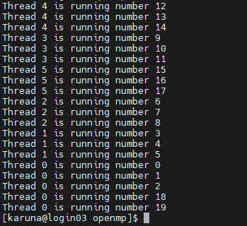

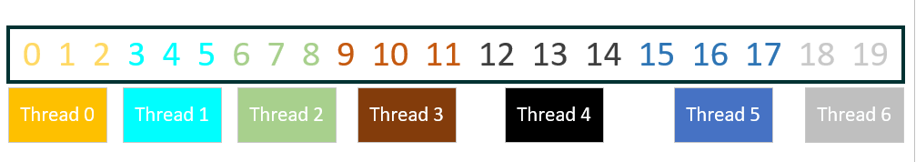

omp_set_num_threads(4);

#pragma omp parallel for schedule(static, 3)

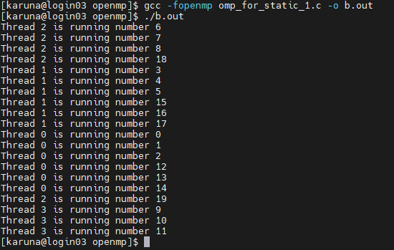

omp_set_num_threads(4);

#pragma omp parallel for schedule(static, 5)

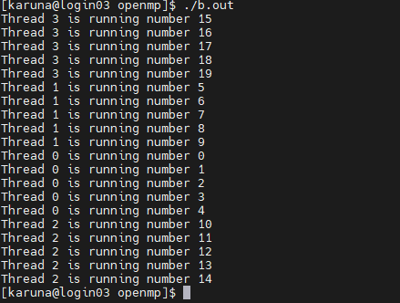

What if the chunk size is more than the total no of threads. Here chunk size is 8

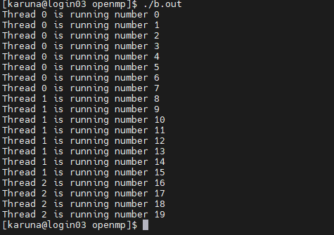

OpenMP will still split task into 8 chunks, but distributes the chunks to threads **in a circular order**, like the following figure shows

**Dynamic**

OpenMP will still split task into iteration_size/ chunk_size chunks, but distribute trunks to threads dynamically without any specific order.

omp_set_num_threads(4);

#pragma omp parallel for schedule(dynamic, 1)

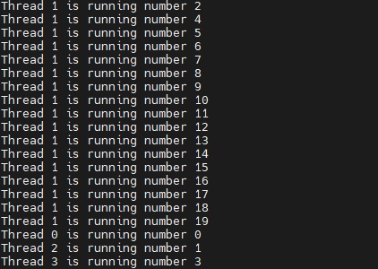

omp_set_num_threads(4);

#pragma omp parallel for schedule(dynamic, 2)

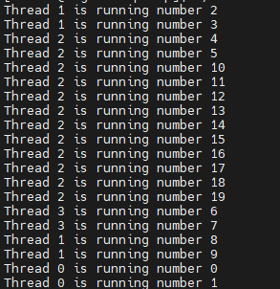

**Comparison between dynamic and static**

**Pros: The dynamic scheduling type is appropriate when the iterations require different computational costs. This means that the iterations are not as balance as static method between each other.**

**Cons: The dynamic scheduling type has higher overhead then the static scheduling type because it dynamically distributes the iterations during the runtime**

**Guided**

Chunk size is dynamic while using guided method, the size of a chunk is proportional to the number of unassigned iterations divided by the number of the threads, and the size will be decreased to chunk-size(but the last chunk could be smaller than chunk-size)